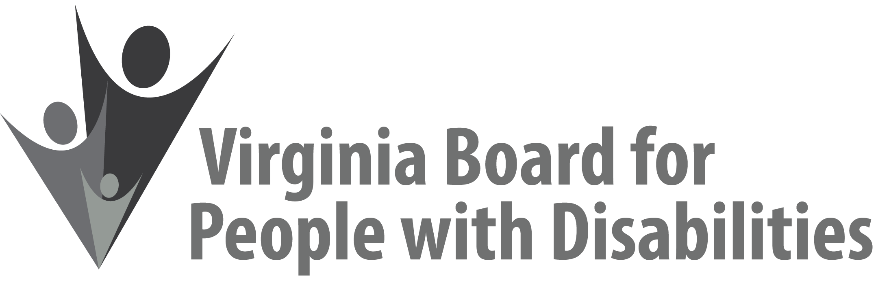

**Mission**To create a Commonwealth that advances opportunities for independence, personal

decision-making and full participation in community life for individuals

with developmental and other disabilities.

**Vision**Virginians with developmental and other disabilities direct their own lives

and choose how they live, learn, work, and play.

**STATE PLAN RETREAT AGENDA FOR WEBINAR #1**

**September 2, 2020**

**Introduction to State Plan Development: Overview of State Plan and Related Public Input**

**1:00 pm - 2:00 pm**

<https://zoom.us/j/95393107890?pwd=RGlJYzJPSTMwcTF0ZzFhRzhLeVlHUT09>  
Meeting ID: 953 9310 7890  
Passcode: 039339  
Dial by your location  
        +1 301 715 8592 US (Germantown)  
        +1 312 626 6799 US (Chicago)

1:00 Welcome & Overview of State Plan Development, Nia Harrison

1:15 Remarks from Federal Technical Assistance Staff, Sheryl Matney

1:35 Summary of Input from the Public and Board Members(**Attachments SPA 2 and SPA 3**), Nia Harrison

1:45 Questions and Discussion **(Attachment SPA 4**), Nia Harrison

2:00 Adjourn